**Ideation Brainstorm & Idea Prioritization phase**

**Team ID: LTVIP2025TMID29114**

**Project Name: Sustainable Smart City Assistant Using IBM Granite LLM**

The ideation phase focuses on identifying the core problems, exploring feasible solutions, and brainstorming innovative ideas to address user needs. This phase lays the groundwork for the entire development lifecycle by converting abstract concepts into concrete project goals. It includes understanding stakeholder expectations, analyzing existing systems, and exploring advanced technologies to bring meaningful value.

**Idea Prioritization – Sustainable Smart City Assistant**

In the Sustainable Smart City Assistant project, idea prioritization is crucial to ensure that the most impactful, feasible, and scalable modules are selected for development. The goal is to integrate AI and data-driven insights into city governance, sustainability practices, and citizen interaction through a unified digital assistant.

**Step 1: Team Gathering, Collaboration and Select the Problem Statement**

Problem Chosen:

Lack of intelligent, real-time decision support and citizen engagement in urban governance limits the effectiveness of sustainability efforts, resource management, and public service delivery in smart cities.

**Goal:**

Design a generative AI-powered Smart City Assistant that leverages large language models and machine learning to support policy summarization, citizen feedback analysis, KPI forecasting, and sustainability guidance — enabling data-driven decision-making, increased transparency, and improved citizen participation in city development.

**Step 2: Features Overview**

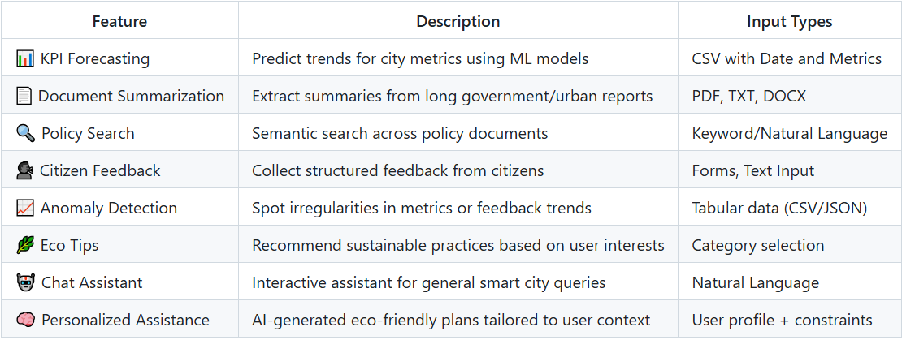

**Step 3:** **Idea Prioritization**

